**Taking Morphology Measurements with the ZEISS microscope**

Main morphology measurements (see example on step 9) :

**body length**: measurement from the most protruding part of the SBB head to the wing (not body) edge.

**wing length**: measurement from the edge of the pronotum to the edge of the wing.

**thorax length**: measurement from the right-most edge of the pronotum to the left-most edge of the pronotum

**beak length**: measurement from the farthest most edge of the beak away from the head to the farthest most edge of the beak away from the body.

Units on datasheet: **mm**

Units on microscope: **um**

1. Turn on the Dell desktop and login using set username and password.
2. Turn on the microscope and the lights behind the microscope by hitting their switches. Those lights will help reduce shadows casted by the bug. Adjust your light intensity as needed by turning the dials.
3. Open the software called ZEN3.1 by double clicking the ZEN3.1 icon on the Desktop and select “ ZEN Pro” on the pop up window.

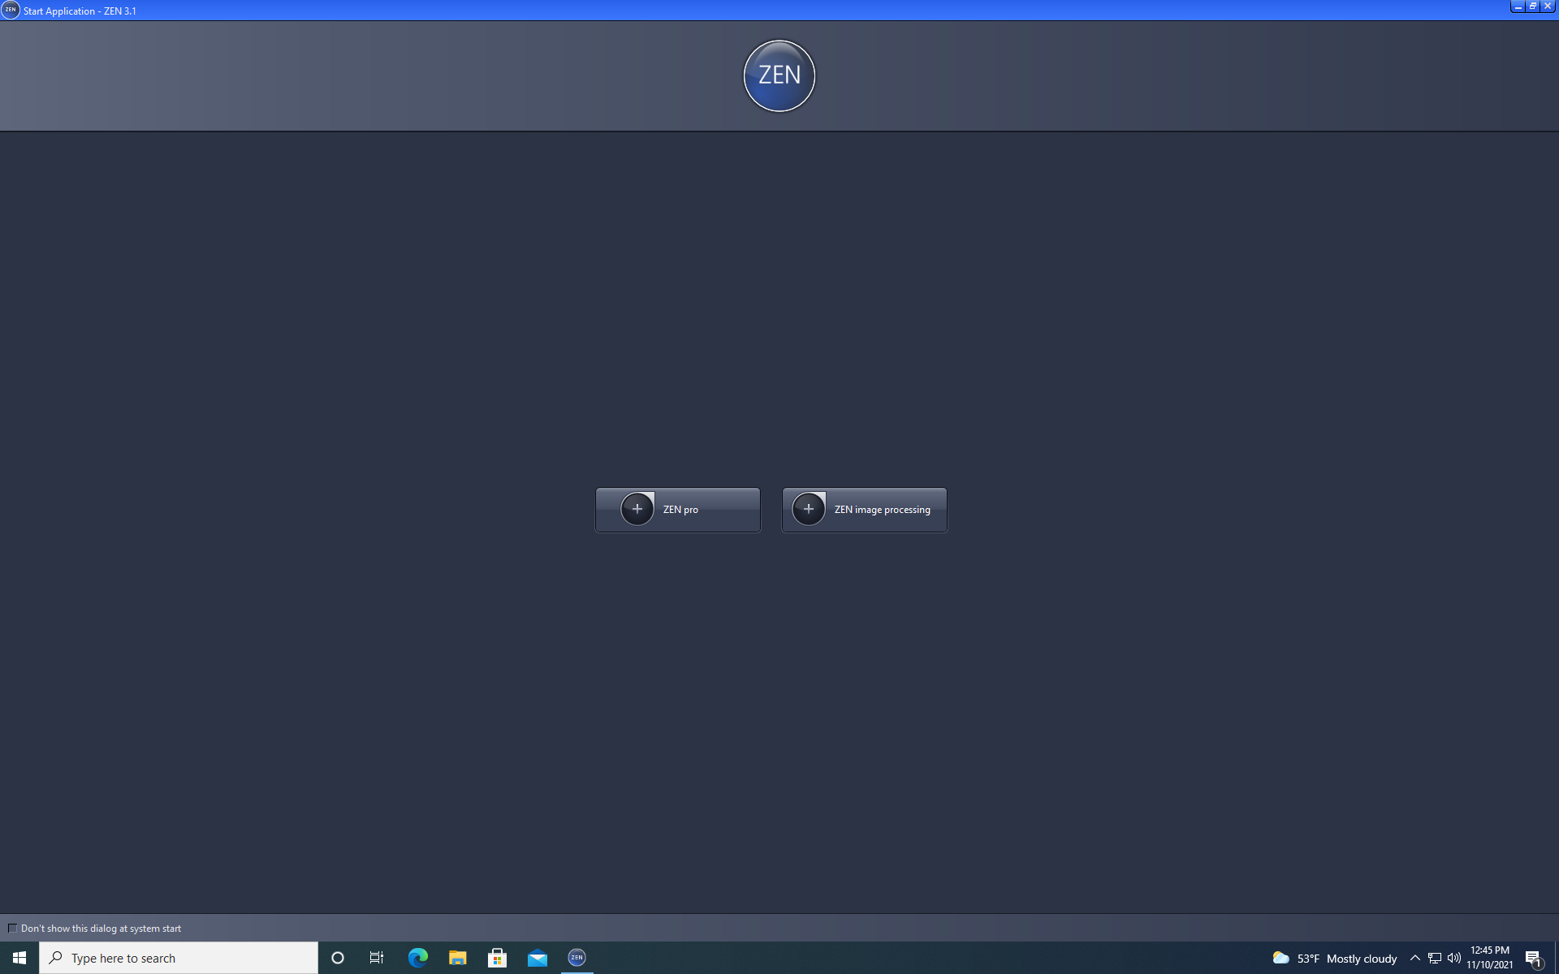

1. Place bug for measurement under the microscope and on top of a piece of index paper for easier positioning. Two positions are needed for SBB morphology measurements: a dorsal view and a ventral view. For either view, begin by spreading the legs open using the forceps. Then, make sure either head and wing (for dorsal) or the beak (for ventral) and on the same **parallel plane to the microscope base**.
2. To begin a live view of the insect, select the **Locate** tab and click the **Live** button on the left-hand window.

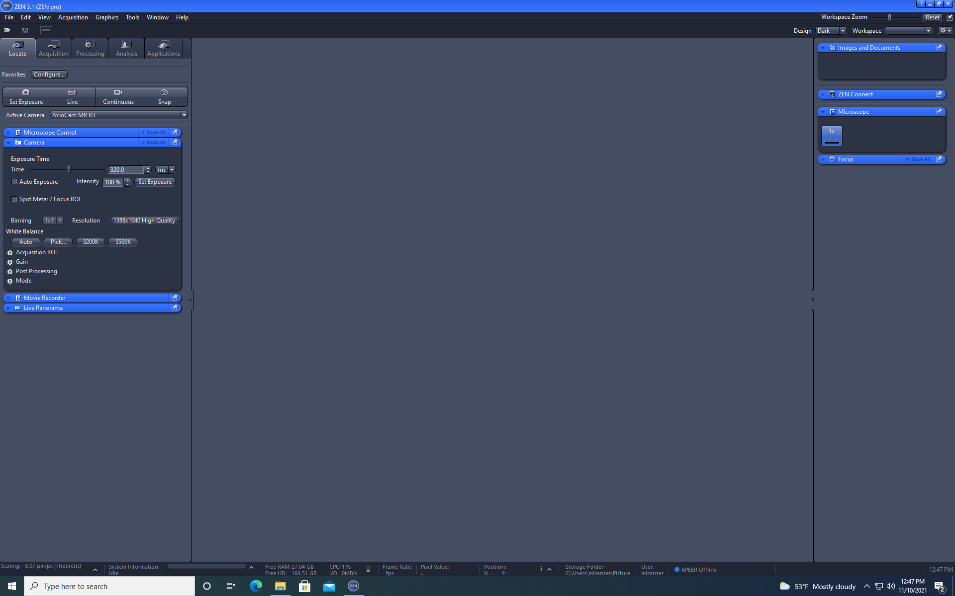 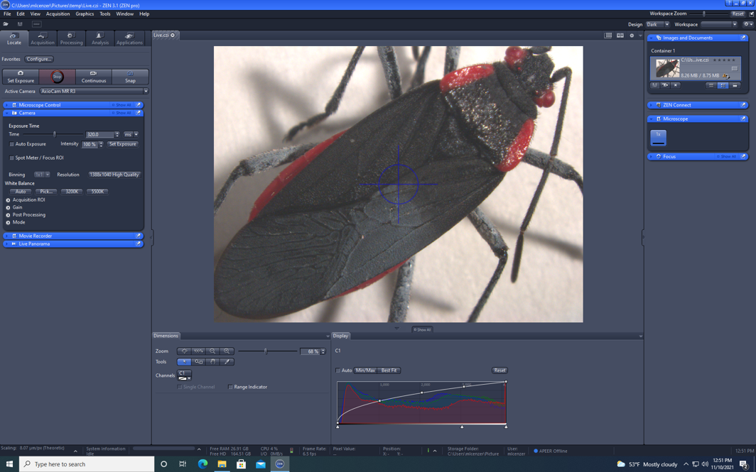

1. Adjust the focus of the microscope as needed by **pushing forward** the joy stick of the microscope **to zoom out** and **pulling down to zoom in**.
2. When ready, press the **Snap** button within the Locate tab and select the image in the new tab generated.

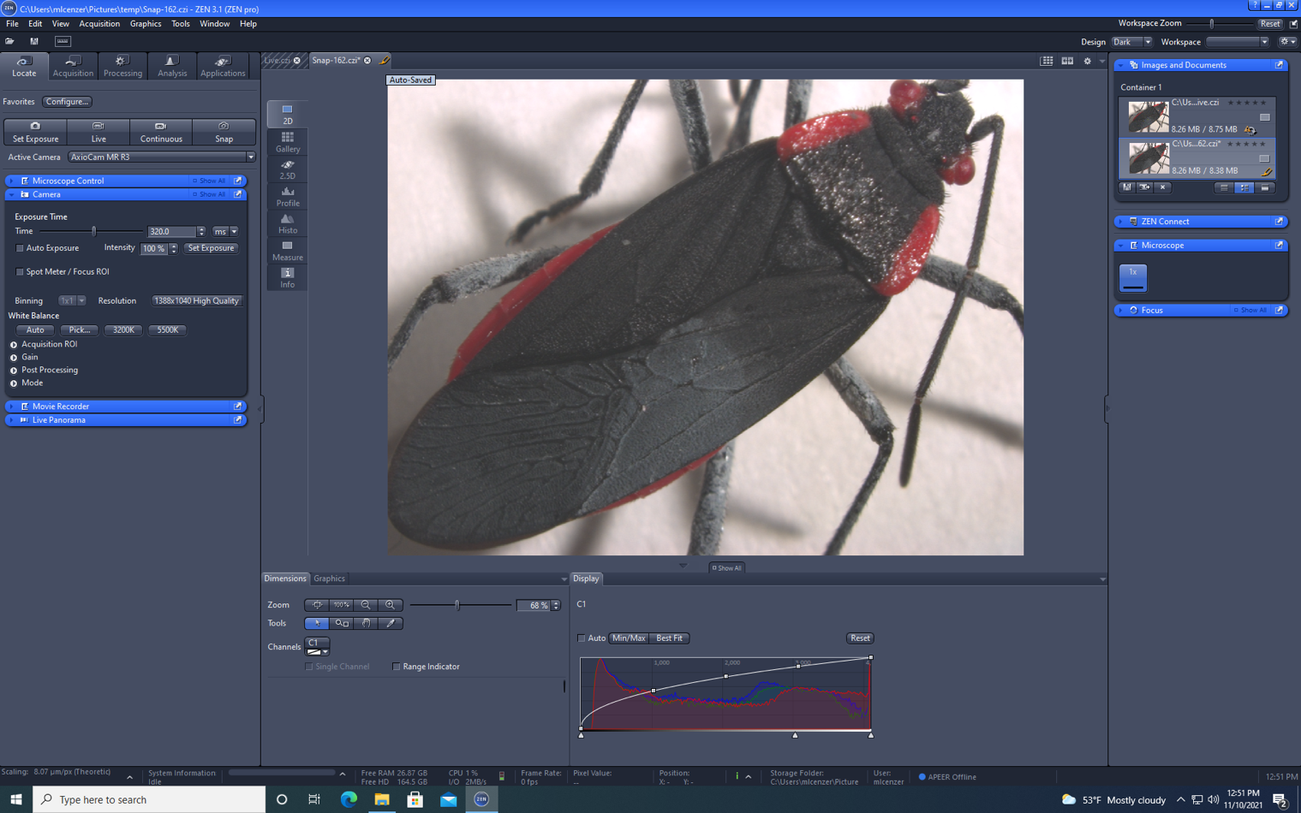

1. Select the **Analysis** tab on the left-hand window and then click on the **Graphics** drop menu down located at the top navigation bar. Within **Graphics**, select **Distance** > **Length**.

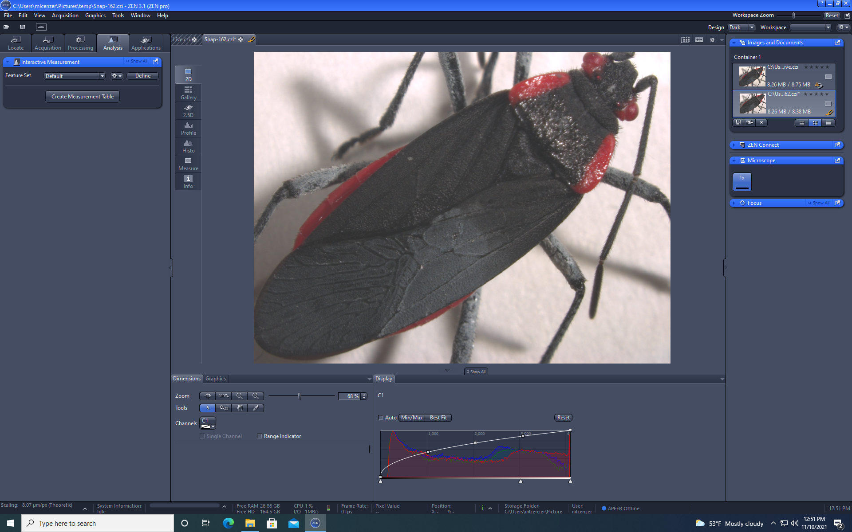 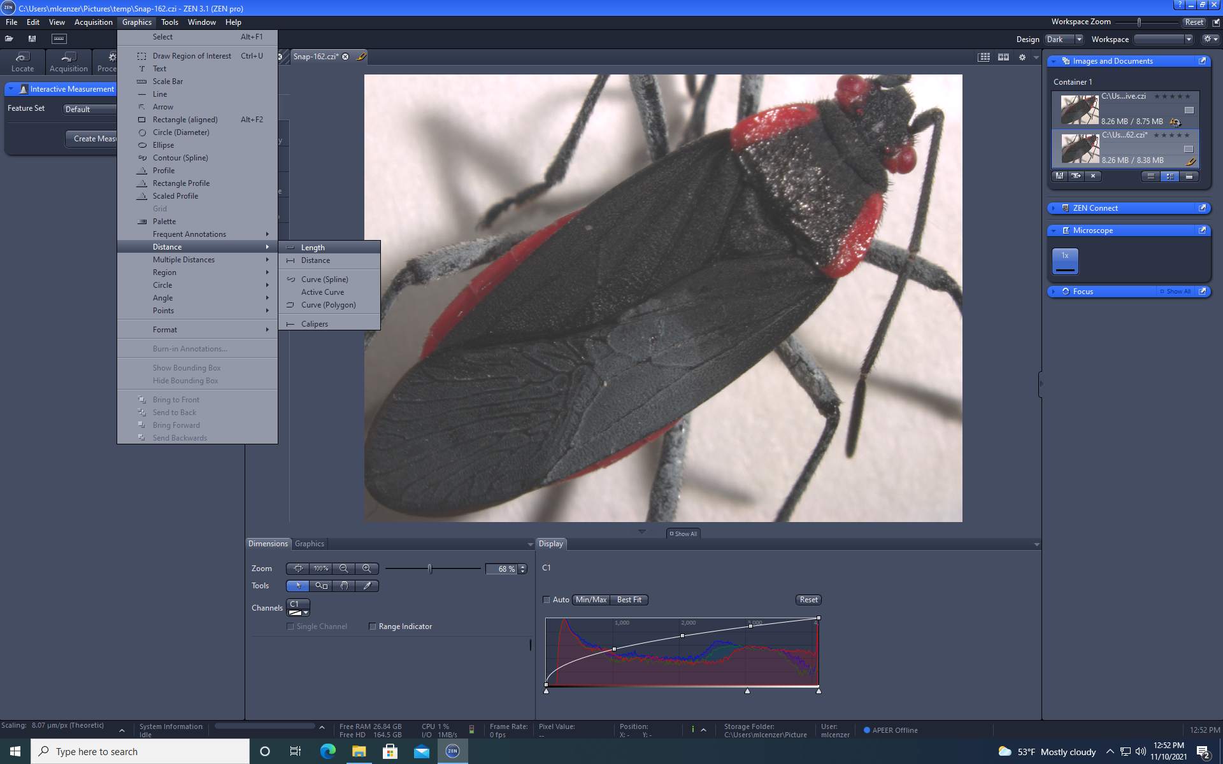

1. Take the length measurement of the body, wing, and thorax by clicking on the image location you want to begin your measurement. Then, drag from one edge to the other. Note: Measurements are in micrometers (um), so convert to millimeters (mm) when record on the datasheet.

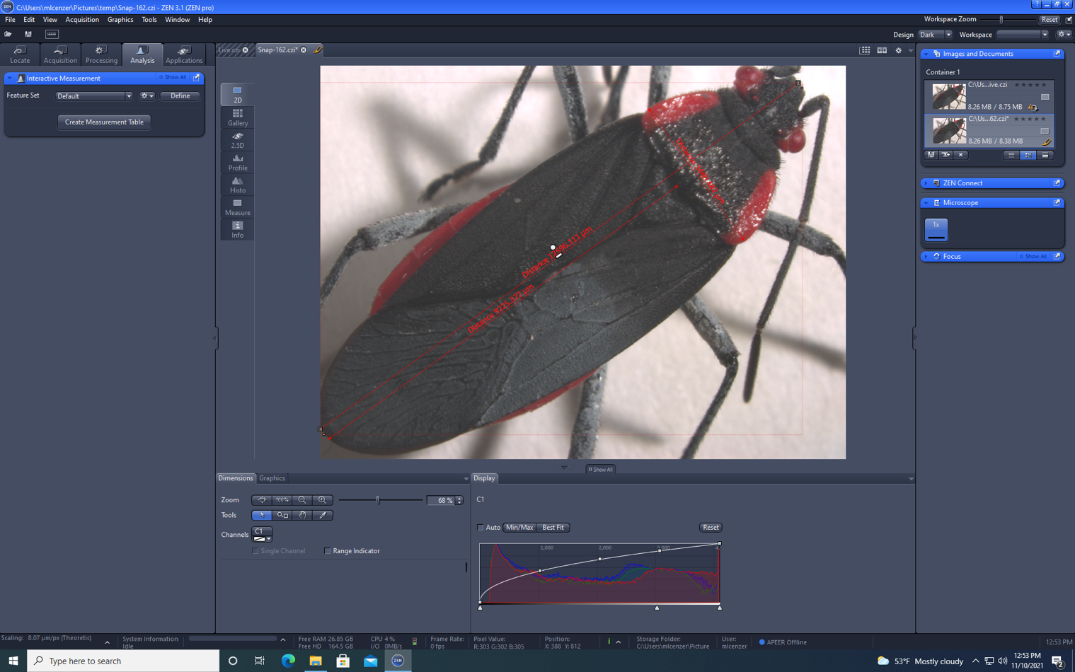

1. In the bottom window below the snapshot, select the **Graphics** tab and rename each name field to their corresponding insect part. E.g. rename “Length” to “body”, “wing”, or “thorax”.

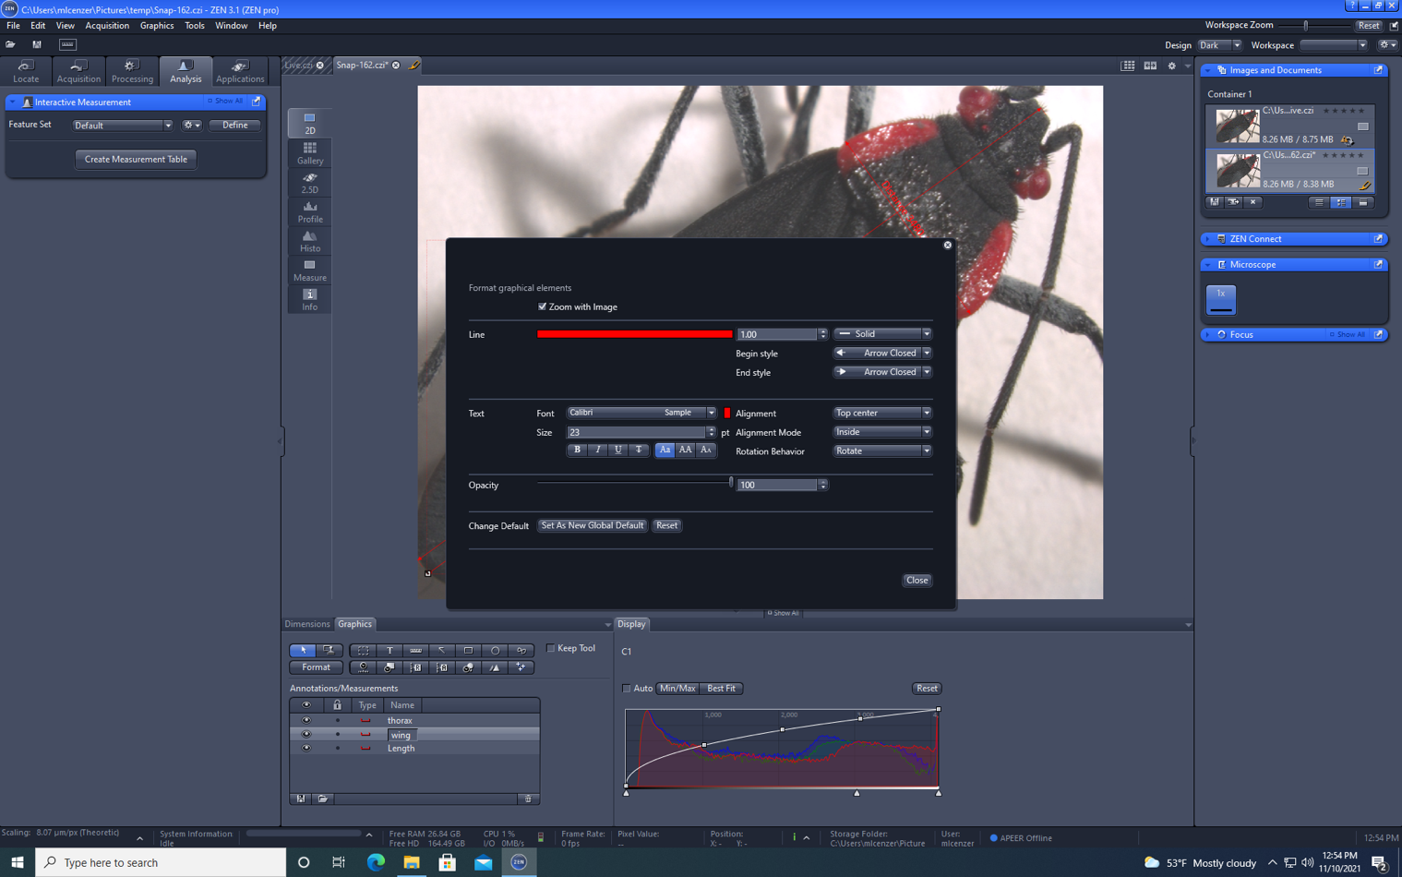

1. On the left-hand tabs within the snapshot, click on the **Measure** tab to see your measurements and record them on the datasheet.

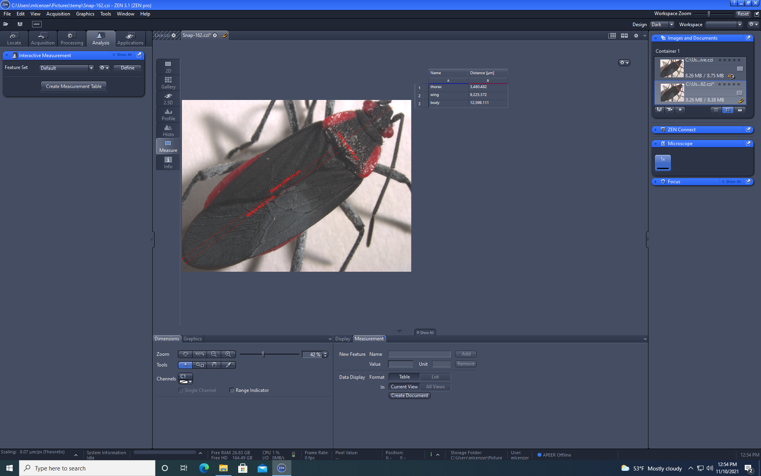

1. **Ctrl + S** to save the snap and give the **.czi file** an identifiable name such as <ID>_SBB_dorsal.
2. Go back to the live view by selecting the **Live.czi** tab next to the snap tab and repeat steps 4-12 for the next position of the SBB.

